**Notes – Ch18 Time Series Analysis and Forecasting**

**Ch14 Regression**

Forecasting methods can be classified as

1. Qualitative
2. Quantitative.

**Qualitative methods** generally involve the use of expert judgment to develop forecasts. Such methods are appropriate when historical data on the variable being forecast are either not applicable or unavailable.

**Quantitative forecasting methods** can be used when (1) past information about the variable being forecast is available, (2) the information can be quantified, and (3) it is reasonable to assume that the pattern of the past will continue into the future.

A forecast can be developed using

1. Time series method
2. Causal method.

**Time Series Method:** If the historical data are restricted to past values of the variable to be forecast, the forecasting procedure is called a *time series method* and the historical data are referred to as a time series. **A time series** is a set of observations on a variable measured at successive points in time or over successive periods of time. The objective of time series analysis is to discover a pattern in the historical data or time series and then extrapolate the pattern into the future; the forecast is based solely on past values of the variable and/or on past forecast errors.

**Causal forecasting methods** are based on the assumption that the variable we are fore- casting has a cause-effect relationship with one or more other variables.

**Components of Time series:**

**Trend:** Although time series data generally exhibit random fluctuations, a time series may also show gradual shifts or movements to relatively higher or lower values over a longer period of time. If a time series plot exhibits this type of behaviour, we say that a trend pattern exists. A trend is usually the result of long-term factors such as population increases or decreases, cost of living index, changing demographic characteristics of the population, technology, and/or consumer preferences.

1. **Cyclical:** A cyclical pattern exists if the time series plot shows an alternating sequence of points below and above the trend line lasting more than one year. Many economic time series exhibit cyclical behaviour with regular runs of observations below and above the trend line. Often, the cyclical component of a time series is due to **multiyear business cycles**. These are fluctuations that repeat over time, with the period being more than a year from one peak to the next. The sunspot and business cycles are examples of this type of fluctuation. For example, periods of moderate inflation followed by periods of rapid inflation can lead to time series that alternate below and above a generally increasing trend line (e.g., a time series for housing costs). Business cycles are extremely difficult, if not impossible, to forecast.
2. **Seasonal:** The trend of a time series can be identified by **analyzing multiyear movements** in historical data. Seasonal patterns are recognized by seeing the same repeating patterns over successive periods of time. These are also periodic fluctuations, but they repeat over a period of one year or less. For example, a manufacturer of swimming pools expects low sales activity in the fall and winter months, with peak sales in the spring and summer months. Manufacturers of snow removal equipment and heavy clothing, however, expect just the opposite yearly pattern. Not surprisingly, the pattern for a time series plot that exhibits a repeating pattern over a one-year period due to seasonal influences is called a seasonal pattern. While we generally think of seasonal movement in a time series as occurring within one year, time series data can also exhibit seasonal patterns of less than one year in duration. For example, daily traffic volume shows within-the-day “seasonal” behaviour, with peak levels occurring during rush hours, moderate flow during the rest of the day and early evening, and light flow from midnight to early morning. As an example of a seasonal pattern, consider the number of umbrellas sold at a clothing store over the past five years. Retail sales of bathing suits tend to be higher during the spring months and lower during the winter. Likewise, department stores typically do a great deal of their business during the Christmas period, vacation travel peaks during the summer months when children are out of school, and grocery stores may experience greater sales every other week, when employees at a local plant are paid.
3. **Irregular:** The irregular component of time series is the residual or **“catch-all” factor** that accounts for the deviation of the actual time series values from those expected given the effects of trend, cyclic, seasonal components. It is caused by the short-term, unanticipated, and nonrecurring factors that affect the time series. Because this component accounts for the random variability in the time series, it is unpredictable. This component represents random, or “noise” fluctuations that are the result of chance events, such as work stoppages, oil embargoes, equipment malfunction, natural disasters, market crashes or other happenings that either favourably or unfavourably influence the value of the variable of interest. Random variation can make it difficult to identify the effect of the other components**.**

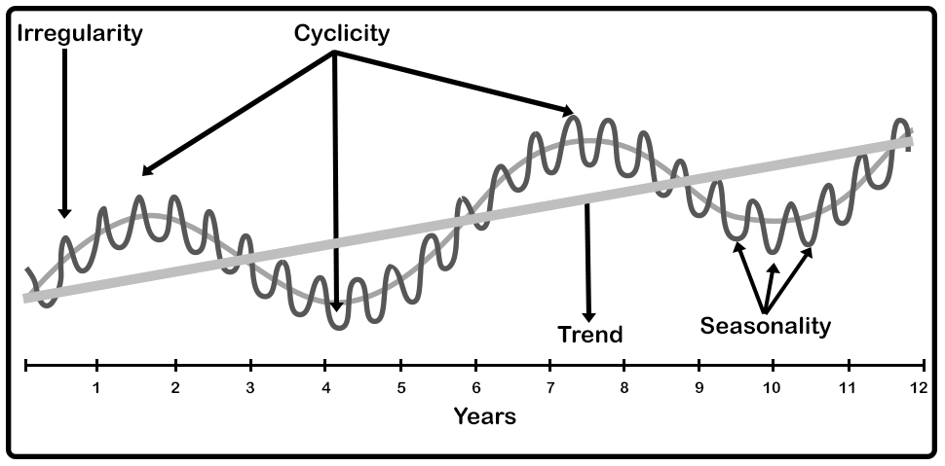

**Smoothing Methods:** The moving averages, weighted moving averages, and exponential smoothing methods also adapt well to changes in the level of a horizontal pattern. However, without modification they are not appropriate when significant trend, cyclical, or seasonal effects are present. Because the objective of each of these methods is to “smooth out” the random fluctuations in the time series, they are referred to as smoothing methods. These methods are easy to use and generally provide a high level of accuracy for short- range forecasts, such as a forecast for the next time period.

1. **Moving Average:** The moving averagesmethod uses the average of the most recent ndata values in the time series as the forecast for the next period. The term *moving* is used because every time a new observation becomes available for the time series, it replaces the oldest observation in the equation and a new average is computed. As a result, the average will change, or move, as new observations become available.

**Forecast accuracy:** The key concept associated with measuring forecast accuracy is forecast error, defined as

Forecast Error = Actual Value – Forecast

A measure that avoids the problem of positive and negative forecast errors off- setting each other is obtained by computing the average of the squared forecast errors. This measure of forecast accuracy, referred to as the mean squared error, is denoted MSE. To determine if a moving average with a different order *k* can provide more accurate forecasts, we recommend using trial and error to determine the value of *k* that minimizes MSE.

1. **Weighted moving averages:** In the moving averages method, each observation in the moving average calculation receives the same weight. One variation, known as weighted moving averages, involves selecting a different weight for each data value and then computing a weighted average of the most recent *k* values as the forecast. In most cases, the most recent observation receives the most weight, and the weight decreases for older data values.

**Forecast accuracy:** To use the weighted moving averages method, we must first select the number of data values to be included in the weighted moving average and then choose weights for each of the data values. In general, if we believe that the recent past is a better predictor of the future than the distant past, larger weights should be given to the more re- cent observations. However, when the time series is highly variable, selecting approximately equal weights for the data values may be best. The only requirement in selecting the weights is that their sum must equal 1. To determine whether one particular combination of number of data values and weights provides a more accurate forecast than another combination, we recommend using MSE as the measure of forecast accuracy. That is, if we assume that the combination that is best for the past will also be best for the future, we would use the combination of number of data values and weights that minimizes MSE for the historical time series to forecast the next value in the time series.

1. **Exponential smoothing:** Exponential smoothingalso uses a weighted average of past time series values as a fore- cast; it is a special case of the weighted moving averages method in which we select only one weight—the weight for the most recent observation. The weights for the other data values are computed automatically and become smaller as the observations move farther into the past. The exponential smoothing equation follows:

*F*t+1 = *αY*t + (1 - *α*)*F*t

*F*t+1 = forecast of the time series for period t+1

*Y*t = actual value of the time series in period t

*F*t  = forecast of the time series for period t

α = smoothing constant (0<= α <=1)

Equation shows that the forecast for period t+1 is a weighted average of the actual value in period *t* and the forecast for period *t*. The weight given to the actual value in period *t* is the **smoothing constant** *α* and the weight given to the forecast in period *t* is 1 – *α*. It turns out that the exponential smoothing forecast for any period is actually a weighted average of *all the previous actual values* of the time series. Let us illustrate by working with a time series involving only three periods of data: *Y*1, *Y*2, and *Y*3. To initiate the calculations, we let *F*1 equal the actual value of the time series in period 1; that is, *F*1= *Y*1. Hence, the forecast for period 2 is

*F*2 = *αY*1 + (1 - *α*)*F*1

*=αY*1 + (1 -*α*)*Y*1

*=Y*1

We see that the exponential smoothing forecast for period 2 is equal to the actual value of the time series in period 1.

The forecast for period 3 is

*F*3 = *αY*2 + (1 - *α*)*F*2

*=αY*2 + (1 -*α*)*Y*1

Finally, substituting this expression for *F*3 in the expression for *F*4, we obtain

F4 = αY3 + (1 - α)F3

=αY3 + (1 -α)[ αY2 (1- α)Y1]

= *αY*3 + *α* (1 - *α*)*Y*2 + (1 -*α*)2*Y*1

We now see that *F*4 is a weighted average of the first three time series values. The sum of the coefficients, or weights, for *Y*1, *Y*2, and *Y*3 equals 1. A similar argument can be made to show that, in general, any forecast *F* is a weighted average of all the previous time series values. Despite the fact that exponential smoothing provides a forecast that is a weighted average of all past observations, all past data do not need to be saved to compute the fore- cast for the next period. In fact, equation shows that once the value for the smoothing constant α is selected, only two pieces of information are needed to compute the forecast: Yt, the actual value of the time series in period t, and Ft, the forecast for period t. The larger the smoothing constant α the more importance is given to the actual y value for the time period.

**Trend Projection:**

Of the four components of time series, trend represents the long-term direction of the series. One way to describe trend component is to fit a line visually to a set of points on a graph. We can also fit a trend line by the method of least squares. Linear regression can be used to forecast a time series with a linear trend.

The least squares method uses the sample data to provide the values of b0 and b1 that minimize the sum of the squares of the deviations between the observed values of the dependent variable and the estimated values of the dependent variable.

The trend line is given by

Tt = b0 + b1t

Where, Tt = trend value of the time series in period t

b0 = intercept of the trend line

b1 = slope of the trend line

t = time

The slope and the intercept is given by

$b_{1}= \frac{\sum{}tY_{t} –(\sum{}t \sum{}Y_{t})/n}{\sum{}t^{2}-{(\sum{}t)}^{2}/n}$

$b_{0}= \underline{Y}-b_{1}\underline{t}$

$Y_{t}$ = value of the time series in period t

$n=number of periods$

$\underline{Y}$ = average value of the time series $\underline{Y}= \sum{}Y_{t}/n$

$\underline{t}$ = average value of the t, $\underline{t}= \sum{}t/n$

The trend line can be used for forecasting values in the future.

**Regression:**

Regression analysisprovides a “best-fit” mathematical equation for the values of the two variables. The equation may be linear (a straight line) or curvilinear, but we will be concentrating on the linear type. Simple linear regression and correlation because there are just two variables, *y* and *x*. These are called the dependent (y) and independent (x) variables**,** since a typical purpose for this type of analysis is to estimate or predict what *y* will be for a given value of *x*.

The estimated regression equation for simple linear regression is given by:

$\hat{y}= b_{0}+b_{1}x$

The graph of the estimated simple linear regression equation is called the *estimated regression line*; *b*0 is the *y* intercept and *b*1 is the slope. *y*ˆ is the point estimator of

*E*(*y*), the mean value of *y* for a given value of *x.*

**Least Square Method:**The least squares method uses the sample data to provide the values of *b*0 and *b*1 that minimize the *sum of the squares of the deviations* between the observed values of the dependent variable *yi* and the estimated values of the dependent variable *y*ˆ*i*. The criterion for the least squares method is given by

$min⁡\sum{}{(y_{i}- \hat{yi})}^{2}$

$y_{i}$ = observed value of the dependent variable for the *i*th observation

$\hat{yi}=$ estimated value of the dependent variable for the *i*th observation

The least-squares criterionrequires that the sum of the squared deviations between *y* values in the scatter diagram and *y* values predicted by the equation be minimized.

$b_{1}= \frac{\sum{}xy –(\sum{}x\sum{}y/n}{\sum{}x^{2}-{(\sum{}x)}^{2}/n}$

$b_{0}= \underline{y}-b_{1}\underline{x}$

$x$ = value of the independent variable

y = value of the dependent variable

$n=number of obsevations$

$\underline{x}$ = average value of x

$\underline{y}$ = average value of the y